- Introduction to Network Protocols

Q1. Use Wireshark to capture network traffic while you load www.spotify.com in your browser, then identify and note down at least two DNS packets and two HTTP or HTTPS packets in the capture?

Answer
I opened Wireshark, selected the active network interface, started packet capture, and then loaded www.spotify.com in the browser. After the page loaded, I stopped the capture and used display filters to identify DNS and HTTPS/TLS traffic.
- Steps Performed:
1. Opened Wireshark and selected the active Ethernet/Wi-Fi interface.
2. Started packet capture and opened www.spotify.com in the browser.
3. Stopped the capture after the website loaded.
4. Applied the display filter dns to view DNS traffic.
5. Applied the display filter tls to view HTTPS/TLS traffic.
- DNS Packets Identified:

Packet No. | Protocol | Information
- 10147 | DNS | Standard query A for www.gstatic.com
- 10152 | DNS | Standard query response: www.gstatic.com -> 142.251.220.3

These DNS packets were visible in the capture taken during the Spotify browsing session. Modern websites also contact browser, CDN, and security-support domains, so related DNS names may appear along with the main site.
- HTTP/HTTPS Packets Identified:

Packet No. | Protocol | Information
- 13084 | TLSv1.3 | Client Hello (secure HTTPS connection setup)
- 13118 | TLSv1.3 | Server Hello / Change Cipher Spec

- Result
Wireshark successfully captured DNS and HTTPS/TLS traffic during the Spotify browsing session. DNS packets were used for name resolution, while TLS packets were used for secure encrypted communication.
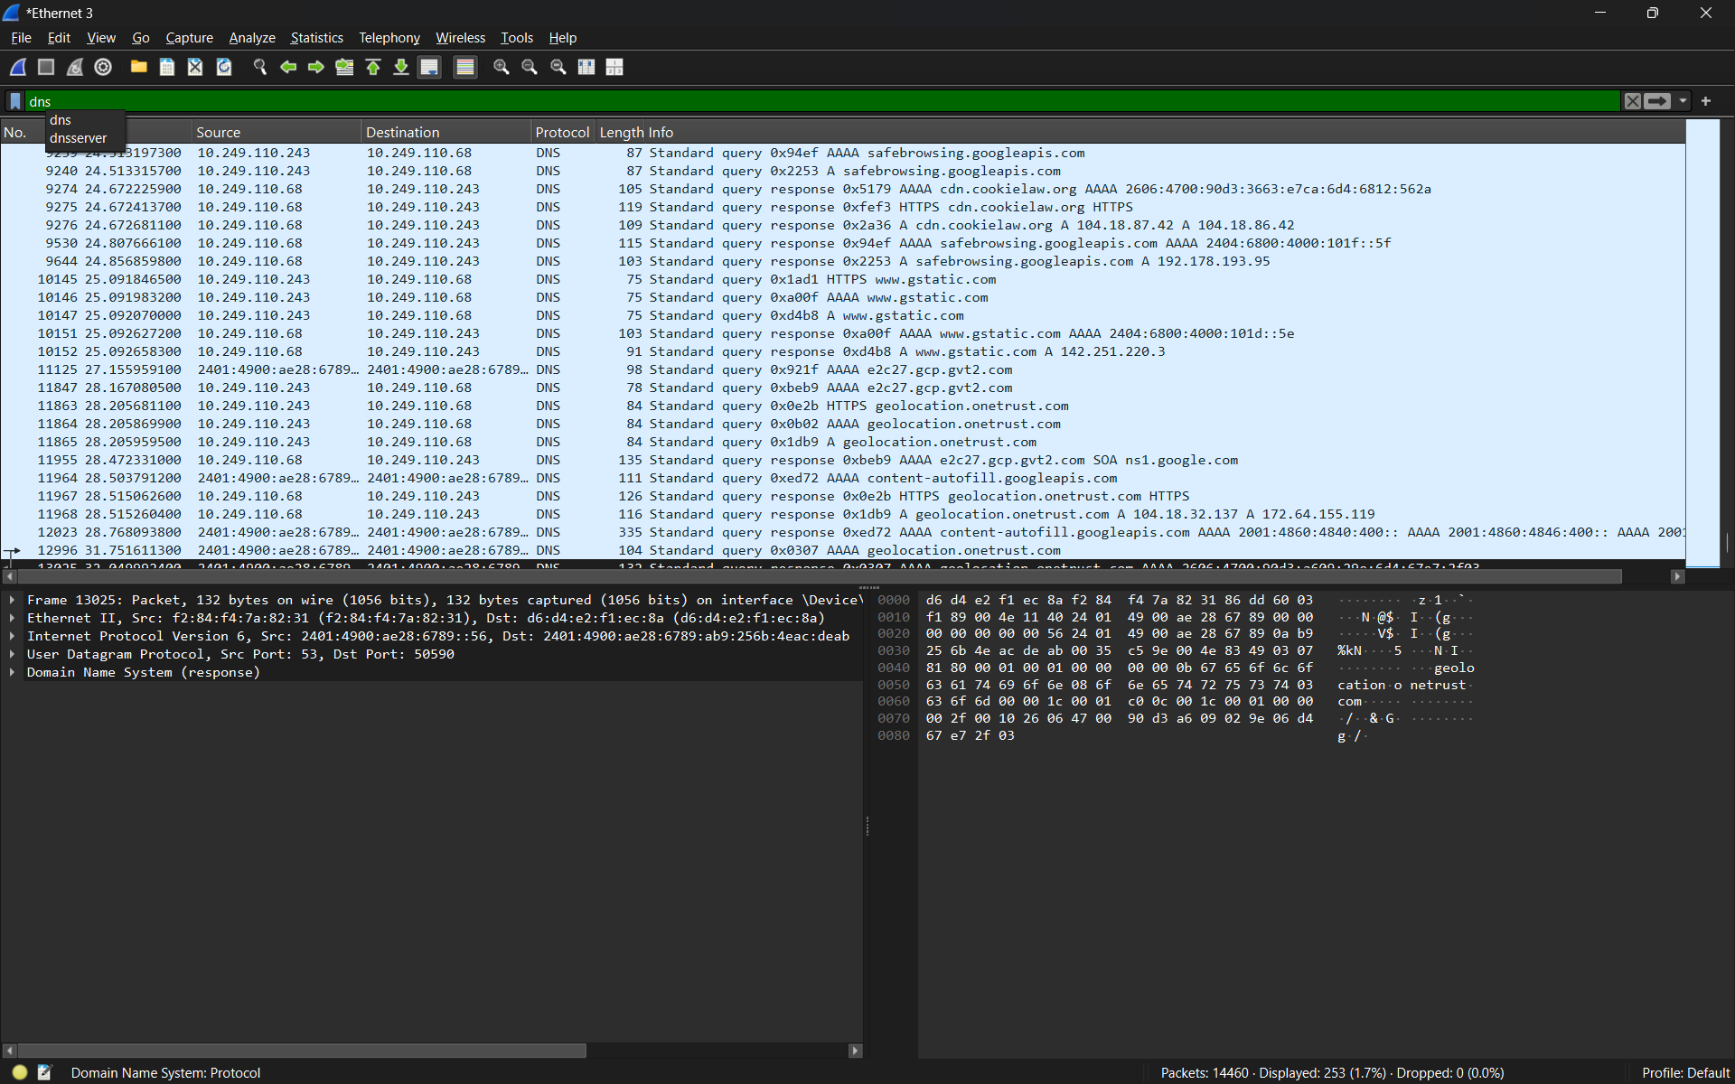
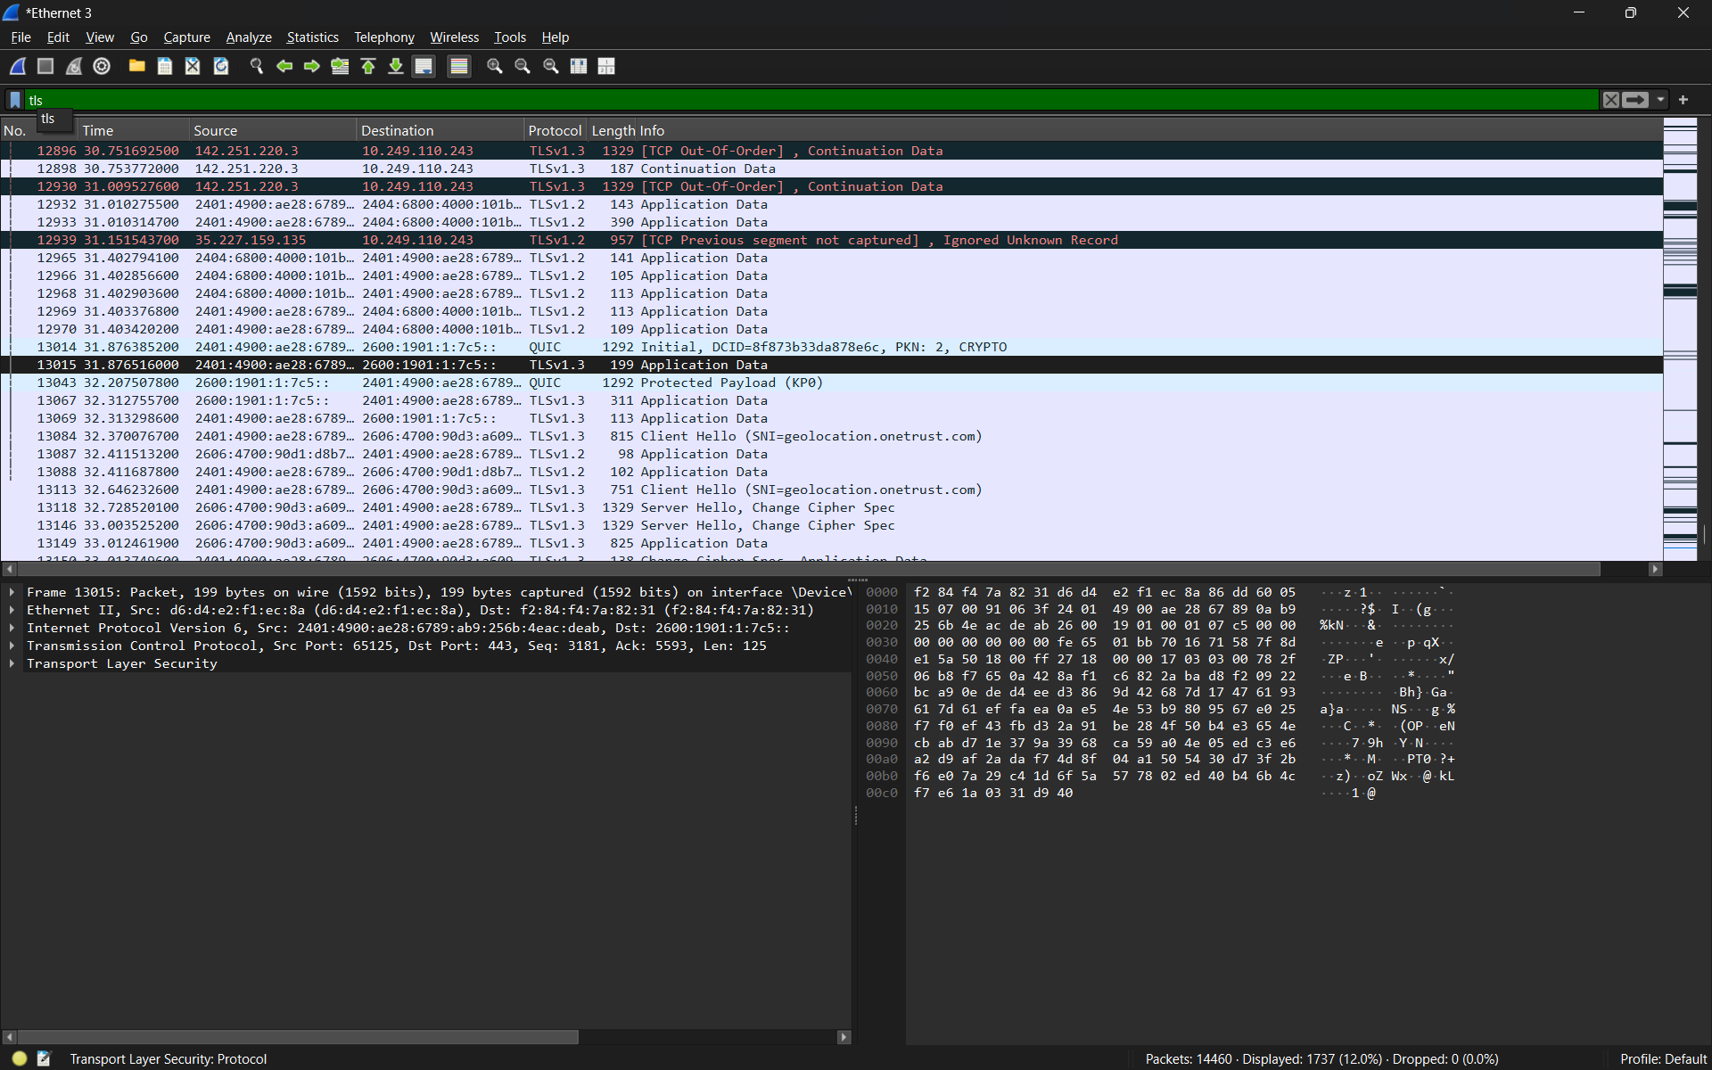

Q2. Simulate a DNS lookup for www.flipkart.com using the nslookup command in your terminal and write down the IP address returned along with a brief explanation of what this result means?
Answer
The nslookup command is used to ask a DNS server for the IP address associated with a domain name.
- Command Used: nslookup www.flipkart.com
- Example Observation:
Domain Name | Returned IPv4 Address
www.flipkart.com | 163.53.76.86 (example)

The exact IP address can change depending on location, DNS server, and CDN routing. The result means that DNS successfully translated the human-readable domain name www.flipkart.com into an IP address that the computer can use to contact the website server.
- Result
The DNS lookup was successful. The domain name was resolved to an IP address, confirming that DNS name resolution was working.

Q3. Explain the difference between HTTP and HTTPS by listing 3 key differences, and give a real-world example of an app or website you use that relies on HTTPS for secure communication?
Answer
HTTP and HTTPS are protocols used for communication between a web browser and a web server. HTTPS is the secure version of HTTP.
Feature | HTTP | HTTPS
- Security | Data is not encrypted. | Data is encrypted using TLS.
- Default Port | Port 80 | Port 443
- Protection | More vulnerable to interception or modification. | Helps protect data from interception and tampering.

- Real-World Example:
Spotify, Instagram, Paytm, and other modern apps/websites use HTTPS to protect login details and other data sent between the user and the service.
- Result:
HTTPS is safer than HTTP because it encrypts the communication and helps verify the website identity.

Q4. Open Wireshark and filter for DNS protocol traffic. Try searching for a new website (one you haven't visited recently) in your browser and describe the sequence of DNS queries and responses you observe. Hint: Look for packets with 'Standard query' and 'Standard query response' in the Info column?
Answer
I opened Wireshark, applied the DNS filter, and then opened a new website in the browser. Wireshark showed DNS query and response packets in the Info column.
- Filter Used: DNS
- Sequence Observed:
1. The client sends a Standard query to the DNS server for the website name.
2. Queries may be sent for an A record (IPv4), an AAAA record (IPv6), and sometimes an HTTPS record.
3. The DNS server sends a Standard query response containing the matching address or DNS information.
4. After receiving the response, the browser uses the returned IP address to connect to the website.
- Example from the Capture:

Type | Observed Information
- Query | Standard query A / AAAA / HTTPS for a domain name
- Response | Standard query response containing an IPv4/IPv6 address

- Result:
The DNS capture showed the normal query-and-response process used to translate a website name into an IP address before the browser connects to the site.
Q5. Pick any one protocol from DNS, DHCP, FTP, or SNMP (other than HTTP/HTTPS) and write a short scenario describing how it would be used in a real-world app or service you use (for example, how DHCP helps your phone connect to WiFi when you open Instagram at a cafe)?

Answer
- Suppose I visit a cafe and connect my phone to the cafe Wi-Fi before opening Instagram. My phone does not already know which IP address to use on that network. The DHCP server automatically gives the phone an IP address, subnet mask, default gateway, and DNS server information.
- After receiving these network settings, the phone can communicate with the router and access the Internet. I can then open Instagram without manually entering an IP address.
- Result:
DHCP makes Wi-Fi connection easy by automatically providing the network settings needed by a new device.

